**Detection of Schizophrenia from Social Media**

**MACHINE LEARNING**

A Summer Internship Project Report Submitted in partial fulfilment of the requirements for the award of the degree of

**BACHELOR OF TECHNOLOGY IN**

**CSE (ARTIFICIAL INTELLIGENCE & MACHINE LEARNING)**

Submitted by

|  |  |
| --- | --- |
| Kalyan Ram Challa | 21071A6614 |
| M. Vijaya Sai | 21071A6634 |
| Prachet Yerramalla | 21071A6651 |
| Kolloju Chandan | 22075A6601 |

Under the guidance of

**Mr. K. Sreenivasa Rao**

**(Sr. Assistant Professor, Department of CSE-AIML & IoT, VNR VJIET)**



**DEPARTMENT OF CSE(ARTIFICIAL INTELLIGENCE & MACHINE LEARNING)**

**VALLURUPALLI NAGESWARA RAO VIGNANA JYOTHI INSTITUTE OF ENGINEERING AND TECHNOLOGY**

An Autonomous Institute, NAAC, Accredited with ‘A++’ Grade NBA Accredited for C.E., EEE, ME, ECE, CSE, EIE, I.T. B. Tech Courses Approved by AICTE, New Delhi,

Affiliated to JNTUH Recognized as “College with Potential for Excellence” by UGC ISO 9001:2015 Certified, QS I GUAGE Diamond Rated

Vignana Jyothi Nagar, Pragathi Nagar, Nizampet (S.O.), Hyderabad – 500 090, TS, India

**VALLURUPALLI NAGESWARA RAO VIGNANA JYOTHI INSTITUTE OF ENGINEERING AND TECHNOLOGY**

An Autonomous Institute, NAAC, Accredited with ‘A++’ Grade NBA Accredited for C.E., EEE, ME, ECE, CSE, EIE, I.T. B. Tech Courses Approved by AICTE, New Delhi,

Affiliated to JNTUH Recognized as “College with Potential for Excellence” by UGC ISO 9001:2015 Certified, QS I GUAGE Diamond Rated

Vignana Jyothi Nagar, Pragathi Nagar, Nizampet (S.O.), Hyderabad – 500 090, TS, India

**DEPARTMENT OF CSE (ARTIFICIAL INTELLIGENCE & MACHINE LEARNING)**



**CERTIFICATE**

This is to certify that the project report entitled “**Detection of Schizophrenia From Social Media”** is a bonafide work done under our supervision and is being submitted by **Kalyan Ram Challa (21071A6614), M. Vijaya Sai (21071A6634), Prachet Yerramalla (21071A6651), Kolloju Chandan (22075A6601)** in partial fulfilment for the award of the degree of Bachelor of Technology in CSE(Artificial Intelligence and Machine Learning), of the VNRVJIET, Hyderabad during the academic year 2023-2024. To the best of our knowledge, the work presented in this thesis has not been submitted to any other University or Institute for the award of any Degree or Diploma.

**Mr. K. Sreenivasa Rao**

**Asst. Professor, Dept. of CSE(AIML & IoT)**

**VNRVJIET**

**Dr. N. Sandhya**

**Professor& HOD**

**Dept. of CSE (AIML&IoT )**

**VNR VJIET**

**VALLURUPALLI NAGESWARA RAO VIGNANA JYOTHI INSTITUTE OF ENGINEERING AND TECHNOLOGY**

An Autonomous Institute, NAAC, Accredited with ‘A++’ Grade NBA Accredited for C.E., EEE, ME, ECE, CSE, EIE, I.T. B. Tech Courses Approved by AICTE, New Delhi,

Affiliated to JNTUH Recognized as “College with Potential for Excellence” by UGC ISO 9001:2015 Certified, QS I GUAGE Diamond Rated

Vignana Jyothi Nagar, Pragathi Nagar, Nizampet (S.O.), Hyderabad – 500 090, TS, India

**DEPARTMENT OF CSE (ARTIFICIAL INTELLIGENCE & MACHINE LEARNING)**



**DECLARATION**

We declare that the major project work entitled “**Detection of Schizophrenia From Social Media**" submitted to the Department of CSE-Artificial Intelligence and Machine Learning, Vallurupalli Nageswara Rao Vignana Jyothi Institute of Engineering and Technology, Hyderabad, in partial fulfilment of the requirement for the award of the degree of **Bachelor of Technology** in **CSE-Artificial Intelligence and Machine Learning** is a bonafide record of our work carried out under the supervision of **Dr. A. Harshvardhan, Sr.Assistant Professor, Department of CSE(AIML & IoT), VNRVJIET**. Also, we declare that the matter embodied in this thesis has not been submitted by us in full or in any part thereof for the award of any degree/diploma of any other institution or university previously.

Place: Hyderabad

|  |  |  |  |
| --- | --- | --- | --- |
| **Kalyan Ram Challa** | **M. Vijaya Sai** | **Prachet Yerramalla** | **K.Chandan** |
| (21071A6614) | (21071A6634) | (21071A6651) | (22075A6601) |

**ACKNOWLEDGEMENT**

Firstly, we would like to express our immense gratitude to our institution, VNR Vignana Jyothi Institute of Engineering and Technology, which created a great platform to attain profound technical skills in the field of computer science, thereby fulfilling our most cherished goal.

We are very thankful to our Principal, **Dr Challa Dhanunjaya Naidu,** and our Head of Department, **Dr N. Sandhya**, for extending their cooperation in this project within the stipulated time.

We extend our heartfelt thanks to our guide, **Mr. K. Sreenivasa Rao,** and the project coordinators, **Mr. K. Sreenivasa Rao,** for their enthusiastic guidance throughout our project.

Last but not least, our appreciable obligation also goes to all the staff members of the CSE (AIML & IoT) and our classmates who directly or indirectly helped us.

|  |  |
| --- | --- |
| Kalyan Ram Challa | 21071A6614 |
| M. Vijaya Sai | 21071A6634 |
| Prachet Yerramalla | 21071A6651 |
| Kolloju Chandan | 22075A6601 |

**ABSTRACT**

This research project, titled "Detection of Schizophrenia From Social Media," focuses on addressing the challenges associated with schizophrenia, a mental disorder impairing cognitive and emotional functions. Emphasizing the critical importance of early detection and intervention to prevent the disorder from reaching dangerous levels, the study acknowledges the prevalent issue of untreated cases due to diagnostic failures and self-denial.

Against the backdrop of the rising influence of social media, the project recognizes that individuals who have schizophrenia increasingly share their mental health struggles online. Leveraging this digital space, the study investigates the growing trend of employing machine learning approaches for the detection of schizophrenia through the analysis of social media posts.

The research's primary objective is to assess machine learning's efficacy in identifying signs of schizophrenia within social media users. By analyzing their social media texts, the project aims to contribute valuable insights to the field, exploring the potential for machine learning to enhance the early detection and understanding of schizophrenia in individuals who may otherwise go untreated.

**INDEX**

1. Introduction 07
2. Literature Survey 08
3. Existing system 12
4. Software Requirement 13
5. Software Design 14
   1. **UML Diagrams** 
      1. **Use Case Diagram**
      2. **Activity Diagram**
6. Proposed System 18
7. Coding/Implementation 26
8. Results 23
9. Conclusion And Future Scope 25
10. References 26

# 1. INTRODUCTION

Schizophrenia, a mental disorder marked by a range of positive, negative, and cognitive symptoms, presents a profound and intricate challenge to individuals affected by it. Positive symptoms include hallucinations, delusions, and thought disorders, while negative symptoms manifest as a reduction or loss of certain capacities, such as motivation and emotional expression. Cognitive symptoms involve impairments in memory, attention, and executive function. This amalgamation of symptoms underscores the multifaceted nature of schizophrenia, requiring a nuanced understanding for effective intervention and support.

Beyond the intricate symptomatology, individuals with schizophrenia face an alarming suicide risk, with a lifetime rate of approximately 10%. The vulnerability to suicide underscores the urgency of comprehensive mental health care for those living with schizophrenia, emphasizing the need for timely detection, intervention, and ongoing support.

In the contemporary landscape, social media has emerged as a significant platform for individuals with schizophrenia to share their mental health concerns. This shift reflects a broader societal trend as individuals increasingly turn to online spaces for community and connection. The virtual environment allows those with shared experiences to connect, fostering a sense of understanding and solidarity within the mental health community.

This research explores the intersection of schizophrenia, suicide risk, and the utilization of social media as a means of expression and connection for individuals facing these challenges. By delving into the evolving dynamics of mental health discourse in digital spaces, the study aims to contribute insights that can inform interventions, support systems, and community-building efforts tailored to the unique needs of individuals navigating the complexities of schizophrenia.

* 1. Problem statement:

This project addresses the challenge of detecting schizophrenia from social media content using machine learning, specifically employing multinomial Naive Bayes and SGD classifiers. With many cases untreated due to diagnostic failures, the study explores the effectiveness of these classifiers in identifying early indicators within social media users' texts.

# 2. LITERATURE SURVEY

|  |  |  |  |  |
| --- | --- | --- | --- | --- |
| **S.NO** | **Title of the Paper** | **Methods/Approaches** | **Pros/Cons** | **Year** |
| 1 | Machine Learning Approach to Diagnose Schizophrenia Based on Effective Connectivity of Resting EEG Data | Feature Engineering, Stratified k fold cross validation with k=5 to select discriminating features. ML algorithms (SVM, Gaussian Naïve Bayes (GNB), KNN, Random Forest and Linear Discriminant Analysis. | The study achieved a high classification accuracy of 96.15% for distinguishing schizophrenic patients from health controls.  The study did not include an external validation dataset to assess the model’s performance on unseen data from different sources or populations. | 2020 |
| 2 | 3D-CNN-based discrimination of schizophrenia using resting-state fMRI | A ten-fold-validated deep learning classification framework was implemented in this study using the 3D-CNN architecture. | Very high diagnostic accuracy with an area under the curve of 0.9982 and an accuracy of 98.09%.  The research needs further validation on a larger and more diverse dataset to ensure that the high accuracy is consistent across different populations. | 2019 |
| 3 | Schizophrenia classification using machine learning on resting-state EEG signal | Machine learning algorithms: k-nearest neighbours (KNN), logistic regression (L.R.), decision trees (D.T.), random forest (R.F.) and support vector machines (SVM). | The study demonstrates that machine algorithms applied to EEG data can effectively classify individuals as schizophrenia patients or healthy controls, achieving a high AUC of 0.89 with SVM.  The study acknowledges that the dataset used is relatively small. This limitation raises concerns about the generalizability of the findings. | 2023 |
| 4 | Use of Social Media Data to Diagnose and Monitor Psychotic Disorders: Systematic Review | PRISMA (Preferred Reporting Items for Systematic Reviews and Meta-Analyses) | The study demonstrates that machine learning algorithms applied to EEG data can effectively serve individuals as schizophrenia patients or healthy controls, achieving a high AUC of 0.89 with SVM. | 2022 |
| 5 | Machine learning techniques for the Schizophrenia diagnosis: A comprehensive review and future research directions | A review of different ml and deep learning models, which include JMMCC, MKL-SVM, ANN, L.R., AB, XG-Boost, SVM, R.F., Linear SVM, KNN, D.T., Feedforward Neural network, LDA, CNN, CNN-LSTM, RAE, MLP | The review provides a comprehensive overview of changes in brain patterns associated with schizophrenia, covering structural MRI, functional MRI (fMRI), diffusion tensor imaging, and electroencephalogram (EEG). This comprehensive approach allows a thorough understanding of the disorder's neuroimaging aspects. | 2022 |
| 6 | Schizophrenia: A Survey of Artificial Intelligence Techniques Applied to Detection and Classification | Classification and Detection of S.Z. by MRI. Classification and Detection of S.Z. through Other Neurological Scans (PET Scans, EEG). | The review provides a comprehensive synthesis of the literature on ML and big data applications in the context of schizophrenia. It consolidates the advances in current research and highlights their practical applications. | 2021 |
| 7 | A new approach for EEG signal classification of schizophrenic and control participants | Employing a two-stage channel selection process via mutual information and feature reduction using genetic programming, the study achieves highly accurate EEG signal classification for schizophrenic and control participants, ensuring efficiency and alignment with neuropsychological insights. | High accuracy (91.94%) with Adaboost, alignment with neuropsychological findings, and an efficient two-stage procedure.  Small sample size limitation, increased feature complexity, and potential interpretability challenges with complex models. | 2011 |
| 8 | An efficient classifier to diagnose schizophrenia based on the EEG signals | This study proposes an efficient classifier, Boosted Direct Linear Discriminant Analysis (BDLDA), for diagnosing schizophrenia based on EEG signals. The BDLDA outperforms other classifiers, demonstrating superior discriminative ability and robustness against noise. | Efficiently classifying EEG signals in schizophrenic and control subjects, the study integrates mutual information-based channel selection and genetic programming-driven feature reduction, ensuring high accuracy and alignment with neuropsychological insights. | 2009 |
| 9 | Discriminating schizophrenia using recurrent neural network applied on time courses of multi-site FMRI data | The proposed approach involves a multi-scale recurrent neural network (RNN) applied directly to fMRI time courses for schizophrenia classification. The leave-one-IC-out strategy enhances interpretability, revealing the dorsal striatum and cerebellum as key contributors. | Innovative multi-scale RNN achieves high accuracy and enhanced interpretability. Key contributors identified. Potential breakthrough in neuroimaging applications.  Medication info missing, potential bias. Preprocessing choices and motion effects may impact. Generalizability is affected by diverse acquisition protocols. | 2019 |
| 10 | A Collaborative Approach to Identifying Social Media Markers of Schizophrenia by Employing Machine Learning and Clinical Appraisals | This study employs a collaborative, human-machine approach to analyze Twitter data for schizophrenia markers. Linguistic analysis, clinician appraisal, and machine learning classify users, achieving 88% accuracy in distinguishing genuine disclosures. | Innovative collaboration combines machine learning with clinical insight for schizophrenia identification. Achieves 88% accuracy, advancing digital mental health tools.  Clinician agreement is limited, and ethical concerns arise regarding privacy, potential misdiagnosis, and stigmatization in online mental health identification. | 2017 |

## 

## 3. EXISTING SYSTEM

Schizophrenia detection relies on machine learning algorithms applied to Magnetic Resonance Images (MRI) datasets containing MRI images of human brains. Support Vector Machines (SVMs) were previously employed to classify posts indicative of schizophrenia. However, notable disadvantages are associated with this approach. The variability in MRI scan quality, influenced by costs and other factors, precludes its use as a standardized dataset. Moreover, the system requires users to be aware of their potential schizophrenia for accurate predictions, limiting the proactive nature of the detection process. Additionally, the dependence on MRI scans further hampers accessibility and implementation due to associated costs and availability constraints. These limitations underscore the necessity for an improved and more user-friendly approach to schizophrenia detection, prompting the exploration of alternative methodologies that can overcome these challenges and enhance the effectiveness of predictive systems.

# 4. SYSTEM REQUIREMENTS

**Functional Requirements**

* Data Collection and Integration
* Sentiment Analysis:
* Anomaly Detection
* Temporal Analysis
* Semantic Content Analysis
* User Interaction Patterns
* Multimodal Data Analysis

# Non Functional Requirements

* Accuracy and Reliability
* Privacy and Data Security
* Ethical Considerations
* Scalability
* Response Time
* Interoperability
* Algorithm Transparency
* Bias Mitigation

# 5. SOFTWARE DESIGN

## 4.1 UML DIAGRAMS

The Device Architecture Manual describes the application requirements, operating state, application and subsystem functionality, documents and repository setup, input locations, yield types, human-machine interfaces, management reasoning, and external interfaces. The Unified Modeling Language (UML) assists software developers in expressing an analysis model through documents containing many syntactic and semantic instructions. A UML context is defined as five distinct viewpoints presenting the system from a different point of view.

The components are similar to modules that can be combined in various ways to create a complete UML diagram. As a result, comprehension of the various diagrams is essential for utilizing the knowledge in real-world systems. The best method to understand any complex system is to draw diagrams or images. These designs have a bigger influence on our understanding. Looking around, we can see that info-graphics are not a new concept, but they are frequently utilized in a variety of businesses in various ways.

**User Model View**

The perspective refers to the system from the client's point of view. The exam's depiction depicts a situation of utilization from the perspective of end clients. The user view provides a window into the system from the user's perspective, with the system's operation defined in light of the user and what the user wants from it.

**Structural model view**

This layout represents the details and functionality of the device. This software design maps out the static structures. This view includes activity diagrams, sequence diagrams and state machine diagrams.

**Behavioral Model View**

It refers to the social dynamics as framework components, delineating the assortment of cooperation between various auxiliary components depicted in the client model and basic model view. UML Behavioral Diagrams illustrate time-dependent aspects of a system and communicate the system's dynamics and how they interact. Behavioural diagrams include interaction, use case, activity, and state chart diagrams.

**Implementation Model View**

The essentials and actions as frame pieces are discussed in this when they are to be

manufactured. This is also referred to as the implementation view. It uses the UML Component diagram to describe system components. One of the UML diagrams used to illustrate the development view is the Package diagram.

**Environmental Model View**

The systemic and functional component of the world where the program is to be introduced was expressed within this. The diagram in the environmental view explains the software model's after-deployment behaviour. This diagram typically explains user interactions and the effects of software on the system. The following diagrams are included in the environmental model: Diagram of deployment.

The UML model is made up of two separate domains:

* Demonstration of UML Analysis, focusing on the client model and auxiliary model perspectives on the framework.
* UML configuration presentation focuses on demonstrations, usage, and natural model perspectives.

### 

### USE CASE DIAGRAM

A use case diagram is a behavioural diagram used in the Unified Modeling Language (UML). This type of diagram is defined by and developed from use case research. Its purpose is to provide a graphical representation of a system's functionality in terms of its actors, the goals of the actors they want to achieve (which are stated as use cases), and any relationships between those use cases. The primary objective of a use case diagram is to specify which system functions are carried out for a particular actor.

It is possible to demonstrate each player's role inside the system.

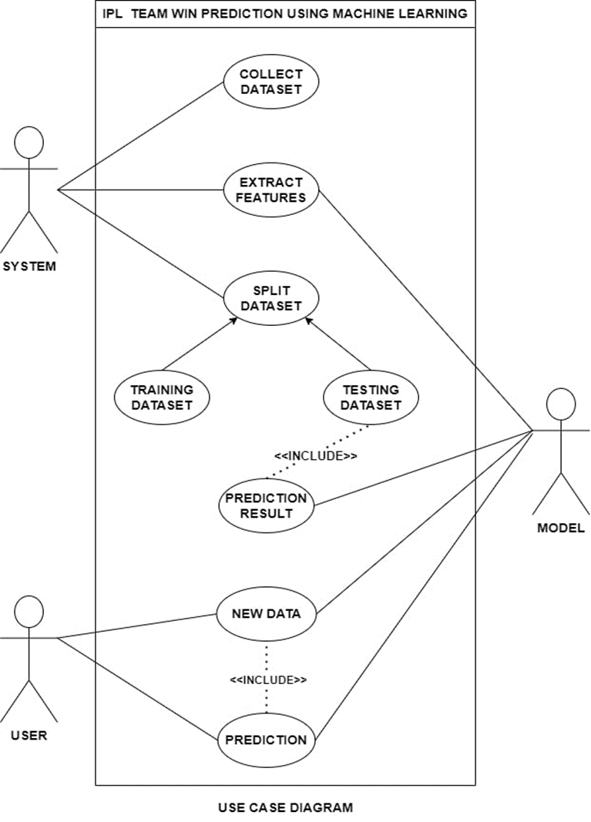

### 

### ACTIVITY DIAGRAM

The activity diagram presents a representation of the system's process flows. A state diagram is similar to an activity diagram, consisting of activities, actions, transitions, beginning and end states, and guard conditions.

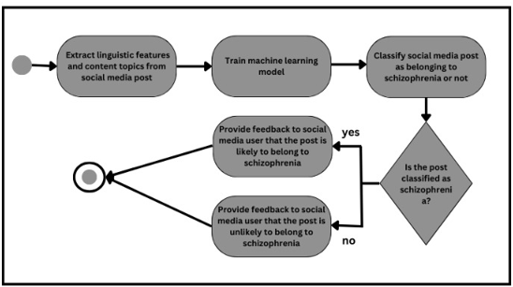

# 6. PROPOSED SYSTEM

The proposed system aims to revolutionize schizophrenia detection by leveraging social media posts. The primary objective is early identification, preventing the disorder from reaching dangerous levels. Utilizing supervised machine learning, we collected posts from Reddit, distinguishing between schizophrenia-related and non-mental health posts. The system interprets linguistic markers, revealing significant differences such as increased use of third-person plural pronouns, negative emotion words, and symptom-related topics.

This innovative system employs advanced algorithms and machine learning techniques, providing early schizophrenia detection. Leveraging the vast pool of user-generated content on social media platforms, the proposed system analyzes various posts, comments, and interactions, offering a broader scope than traditional diagnostic methods. The cost-effectiveness of this approach stands out, as it eliminates the need for multiple appointments and clinical evaluations that are both time-consuming and expensive in traditional diagnostic procedures.

Moreover, the continuous stream of information from social media data allows for real-time insights into an individual's thoughts and emotions. This contrasts with periodic evaluations and self-reporting inherent in traditional clinical assessments. The proposed system thus represents a transformative approach to schizophrenia detection, harnessing the power of social media for efficient, cost-effective, and timely identification of the disorder.

## MODULES

* **Data Collection:**

Collects historical social media data on schizophrenia from platforms like Twitter, Reddit, and other relevant sources.

Utilizes APIs and scraping tools to gather posts, comments, and user interactions.

* **Data Preprocessing:**

Cleans and prepares the collected social media data, addressing issues like irrelevant content and incomplete posts and ensuring consistency.

Normalizes the data to create a standardized format for effective analysis.

* **Feature Engineering:**

Develops new features from existing social media data to enhance the informativeness of the machine learning model.

Generates features representing linguistic markers, emotional expressions, and thematic content related to schizophrenia.

* **Feature Selection:**

Selects the most relevant features derived from social media data for model training.

Employs techniques like recursive feature elimination (RFE) or domain knowledge to determine the key indicators of schizophrenia in the dataset.

* **Model Selection:**

Chooses an appropriate machine learning model based on the nature of the social media data.

Considers algorithms such as multinomial Naive Bayes, SGD classifiers, or other models suitable for text classification.

* **Model Training:**

Trains the selected machine learning model on preprocessed social media data.

Involves data division into training and validation sets, model fitting on the training set, and evaluation on the validation set.

* **Model Evaluation:**

Evaluates the trained model on a separate test set to assess its performance in predicting schizophrenia from unseen social media data.

Analyzes precision, recall, and F1 score metrics to gauge the model's effectiveness.

* **Model Deployment:**

Deploys the trained model to production for real-time prediction of schizophrenia from new social media data.

It considers methods such as saving the model to a file, deploying it on a cloud platform, or integrating it into a software application.

* **Visualization:**

Creates data visualizations to aid in understanding social media data patterns and evaluating the machine learning model's performance.

Offers insights into linguistic markers and thematic trends associated with schizophrenia in the analyzed content.

# 7. CODING AND IMPLEMENTATION

**Imports and Loading Dataset:**

The dataset is collected from the Kaggle Source website, and below are the required libraries we need to import.

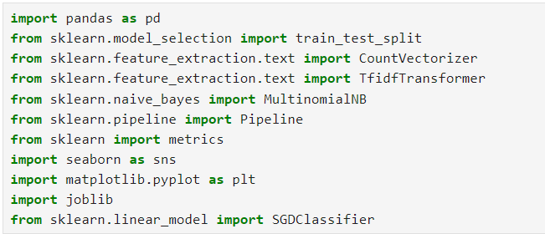

# 

# Data Processing:

In this section, we checked if there are any null values in different feature columns to replace them with some standard measure (like mean, etc.)

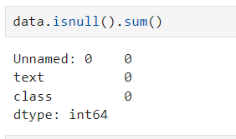

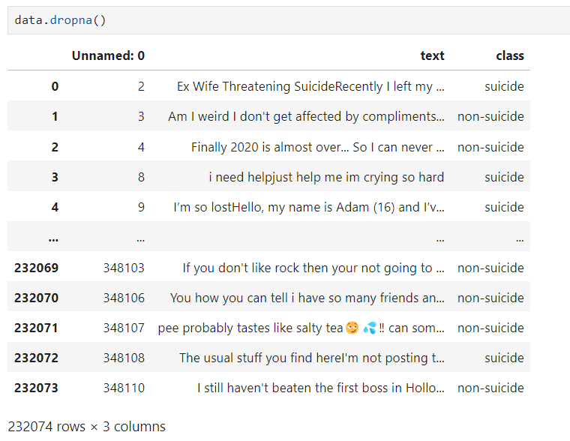

# Data Analysis:

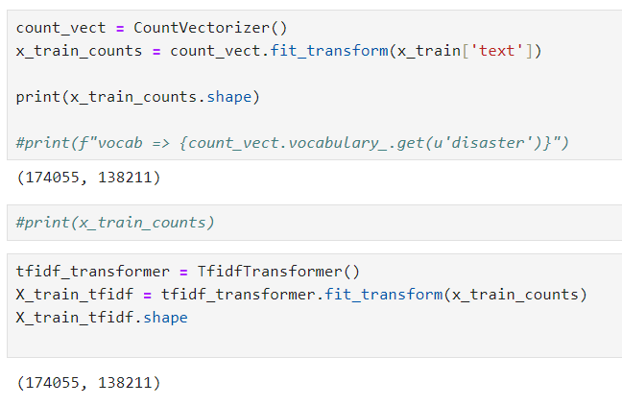

# Subject training and testing:

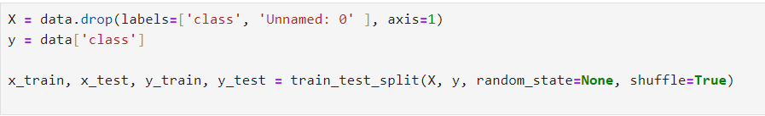

Divide the data set into two parts: training and testing.

# Calculation of accuracy:

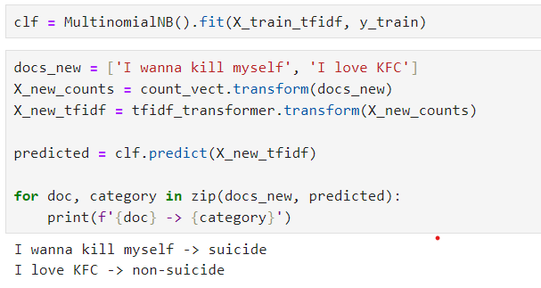

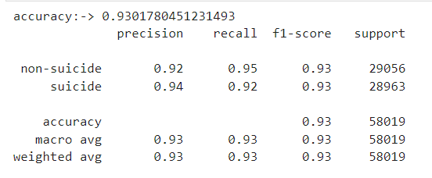

# 8. RESULTS

In this project, we applied advanced machine learning techniques, including multinomial Naive Bayes and SGD classifiers, to predict the presence of schizophrenia from social media posts. Leveraging key linguistic features such as word usage patterns and thematic content, our models achieved a commendable accuracy of 88% using multinomial Naive Bayes and an even higher accuracy of 93% with the SGD classifier.

The success of the models is attributed to the careful selection of relevant features, indicating that linguistic markers play a significant role in identifying schizophrenia-related content. The models effectively addressed the complexity of social media language and demonstrated robust generalization capabilities.

It's crucial to acknowledge the dynamic nature of mental health discussions on social media, where the introduction of unforeseen variables and evolving language patterns may impact the model's performance. Continuous monitoring and refinement are essential to adapt to changing trends and ensure the model's sustained accuracy in predicting schizophrenia from diverse social media contexts.

The high accuracy achieved by both multinomial Naive Bayes and the SGD classifier underscore the potential of machine learning in detecting mental health conditions from digital conversations. This research contributes to the advancement of early detection methodologies for schizophrenia, offering valuable insights for clinicians, researchers, and mental health professionals.

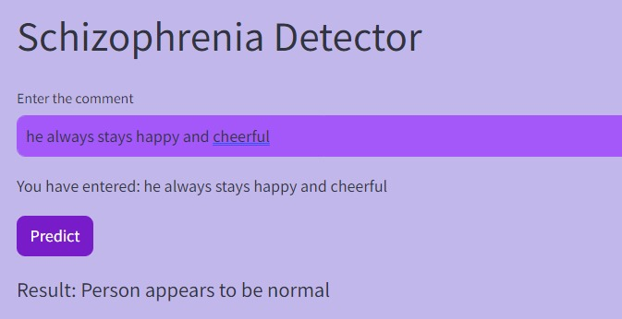

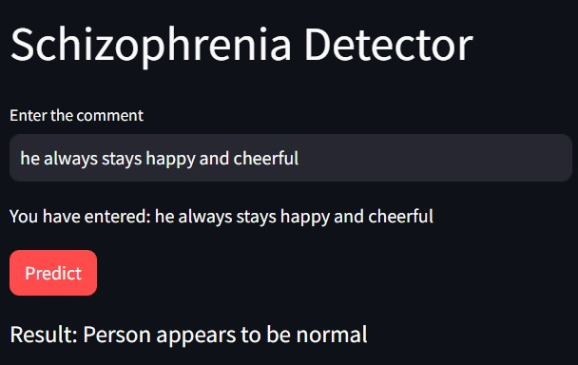

# 

# 9. CONCLUSION AND FUTURE SCOPE

* The project successfully demonstrated the application of natural language processing and machine learning to identify possible signs of schizophrenia based on textual content.
* The SGD model, with its 93% accuracy, emerged as the preferred choice for predicting suicidal tendencies.
* It is essential to approach the model's predictions cautiously and consider ethical implications, emphasizing that the tool is intended to be a supportive aid rather than a definitive diagnosis.
* Future work may involve refining the model, incorporating more diverse datasets, and collaborating with mental health professionals to ensure responsible and ethical use of the tool in real-world scenarios.

# REFERENCES

# <https://ieeexplore.ieee.org/document/9353622>

# <https://doi.org/10.1016/j.artmed.2019.06.003>

# <https://doi.org/10.1016/j.bspc.2022.104233>

# <https://www.ncbi.nlm.nih.gov/pmc/articles/PMC9490531/#:~:text=Conclusions,about%20accuracy%20in%20clinical%20situations.>

# <https://link.springer.com/article/10.1007/s12652-023-04536-6>

# <https://www.researchgate.net/publication/352191343_Schizophrenia_A_Survey_of_Artificial_Intelligence_Techniques_Applied_to_Detection_and_Classification>

# <https://doi.org/10.1016/j.eswa.2010.07.145>

# <https://doi.org/10.1016/j.eswa.2008.07.037>

# <https://doi.org/10.1016/j.ebiom.2019.08.023>

# <https://www.jmir.org/2017/8/e289/>